Attorney General TJ Donovan

109 State Street

Montpelier, VT 05609

June 18, 2020

Dear A.G. Donovan,

We are writing to you to convey serious financial concerns about the non-profit [501(c)3] Democracy Builders Fund (DBF), an entity that, on May 22, 2020, signed a purchase and sale agreement for “the former Marlboro College Campus, consisting of approximately 50 buildings on approximately 533 acres of land”.

Quick basic research has found that:

1) Democracy Builders Fund lost its non-profit status between 11/15/16 and 1/10/2018 *because it failed to file legally required 990’s for at least three years in a row*.[1] In our experience, the only reasons a non-profit would not file 990's for three years in a row are a) lack of knowledge of the legal requirement to do so, b) they are or are going defunct, or c) something untoward is going on. For DBF, the first two reasons are unlikely and irrelevant, respectively. That leaves c).

2) In addition, *DBF has not filed legally required 2017 or 2018 990’s*. The most current 990 filed is DBF’s 2016 return. This means that the most recent public financial information available for DBF is for June 30, 2017 — almost three years ago.

When asked about these missing 990’s in a public Facebook group “Marlboro College Alumni” on May 28, 2020[2], Seth Andrew, the Board Chairman of DBF, refused to answer questions about them, as can be seen in the screenshot of the conversation below[3]:

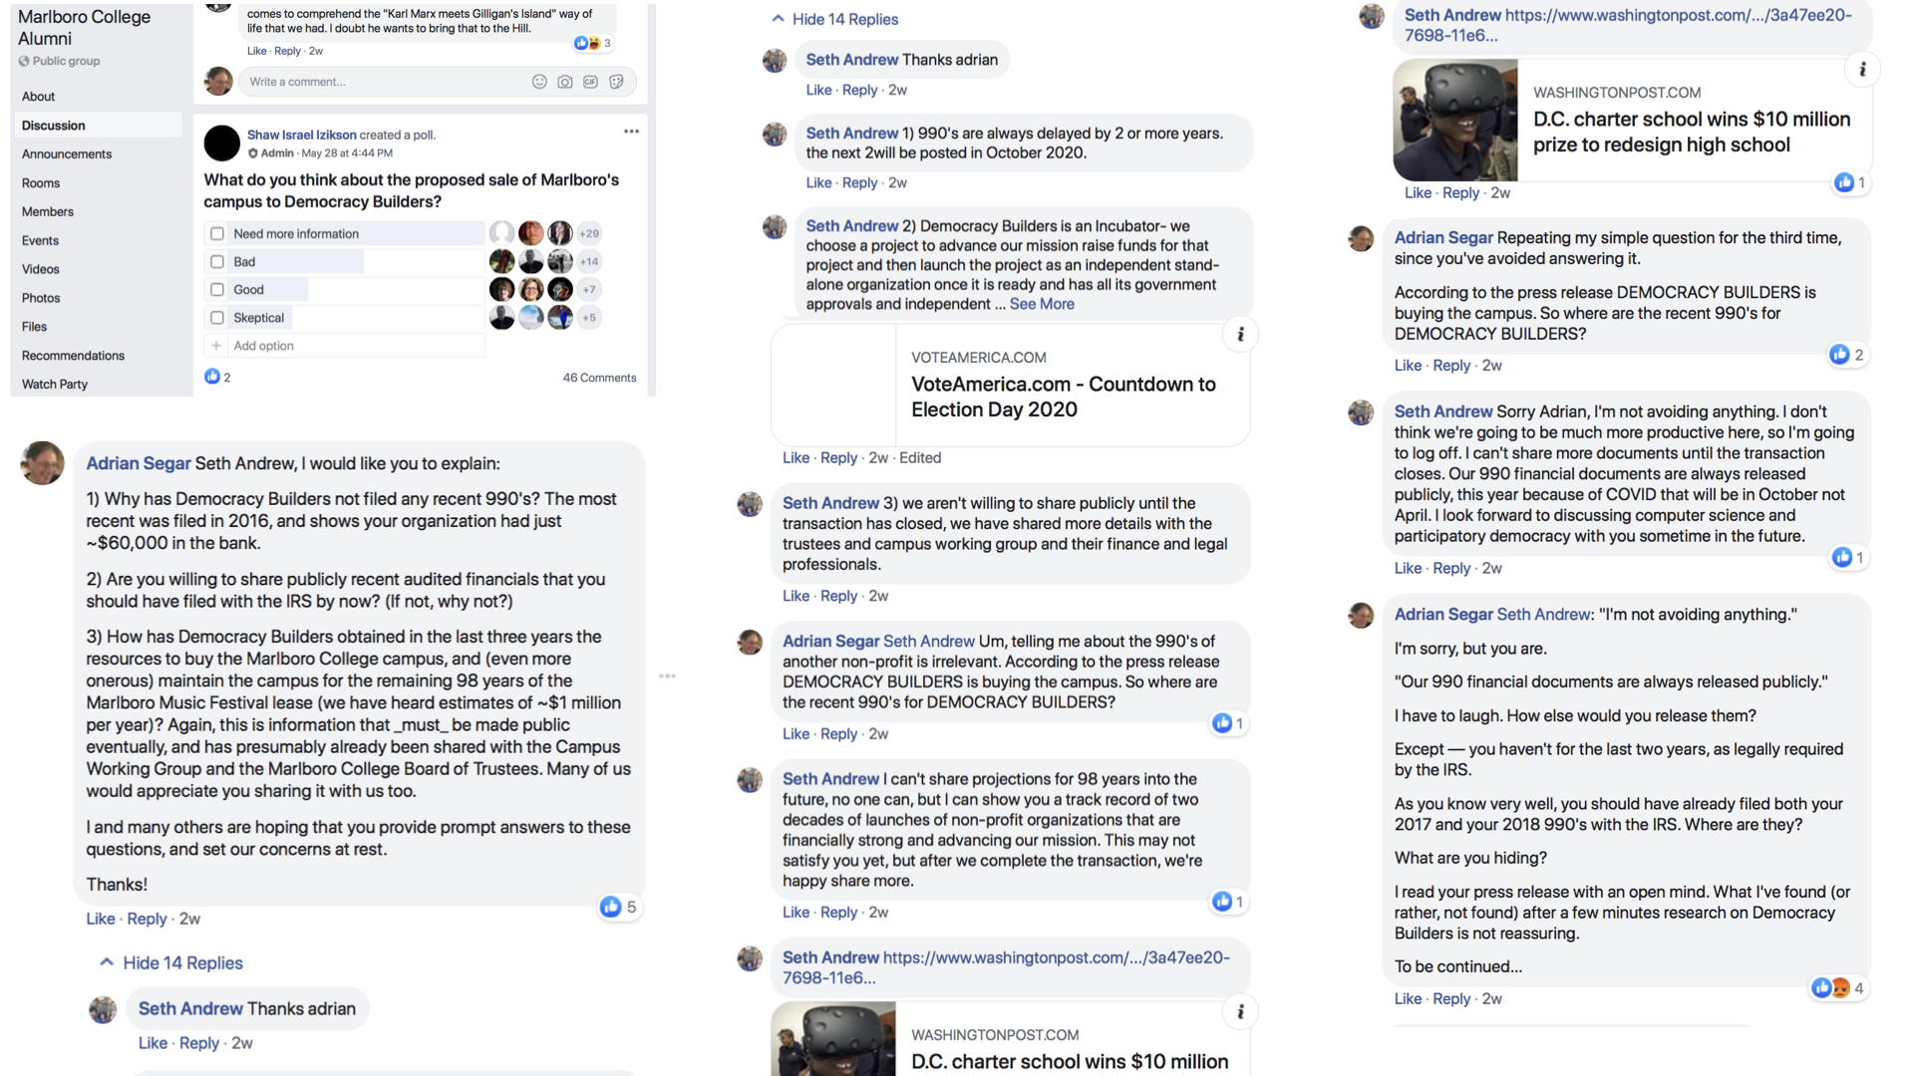

3) The sales price for the Marlboro College Campus is redacted on the purchase and sale agreement. The campus and buildings are fairly valued at ~$10 million, and an expected purchase price of ~$5 million has been publicly stated by the Marlboro College President Kevin Quigley. So we may assume that the sales price is in the order of millions of dollars.

In addition, a much larger financial commitment will be incurred by the purchaser of the campus: the contracted responsibility to maintain the campus for the 99-year life of the Marlboro Music Festival Lease — copy available here[4] or from the Town of Marlboro Office — at a cost publicly stated by Marlboro College President Kevin Quigley to be currently around $1.0 - $1.5 million per year.

So the purchase and sale agreement submitted, commits Democracy Builders Fund to an initial expenditure of millions of dollars, plus subsequent annual expenses of a million dollars or more.

The most recent 990 (2016) for Democracy Builders Fund, the legal entity purchasing the campus, shows end of year current assets of $349,201. Income and Net Assets for the three most recent 990’s available are as follows:

Income EOY Net Assets

2014 $49,865 $296,091

2015 $45,014 $341,105

2016 $237,096 $349,201

These figures show no visible capability for DBF to provide the millions of dollars needed for the purchase of the campus or the millions of dollars needed annually for campus upkeep.

Emerson College has made it clear that they want Marlboro College to sell its campus and associated ongoing liabilities before the Emerson-Marlboro agreement is finalized. Presumably this is because they recognize the significant financial liability of owning a property that, if not put to income-producing use, will drain the owner of a million dollars or more per year for decades.

This creates great pressure for the Trustees of Marlboro College to sell the property before the Emerson deal is signed.

The Attorney General’s letter "6-9-20 Letter Response - Marlboro.pdf" states, the AG’s “review of Marlboro’s proposed transactions (campus sale and agreement with Emerson college) necessarily must be reviewed concurrently given their interrelated nature. To that end, per 11B V.S.A. 12.02(g), we continue to request at least 20 days to review both transactions starting from the time of formal notice of the Marlboro-Emerson transaction.”

**Summary of what is known**

1) Emerson College has made it clear that they want Marlboro College to sell its campus and associated ongoing liabilities before the Emerson-Marlboro agreement is finalized.

2) The Trustees of Marlboro College are, thereby, under great pressure to sell the property before the Emerson deal is signed.

3) Democracy Builders Fund has shown:

— a) A clear pattern of avoiding legally required public filings of its financial statements (*at least five 990’s not filed in timely fashion since the non-profit’s formation in 2014*), and

— b) No obvious capability to fund the purchase of and maintenance of the campus in accordance with the Marlboro Music Festival’s lease.

**What we request**

We request that the Vermont Attorney General thoroughly investigate Democracy Builders Fund to reassure Vermonters that it has a reasonable likelihood of fulfilling its financial obligations under the sales agreement it has signed with the Marlboro College Board of Trustees.

**Conclusion**

Vermonters have had to endure the recent EB-5 fraud scandal involving the Northeast Kingdom Development project, and the consequential five-year old literal “giant hole” in the Town of Newport. We believe that our State and the Town of Marlboro do not want a giant abandoned college campus at its heart, due to the failure of the Office of the Attorney General to perform due diligence on this impending sale.

Yours sincerely,

***Bob Anderson***, Marlboro Town Select Board 1982 – 1988 & 1991 – 1994, and Town resident since 1981

***Jonathan*** ***Morse***, Marlboro Town Select Board 1994 – 2000, and Town resident since 1981

***Lauren Poster***, Marlboro School Board Member and/or Chair 2003 – 2012 & 2016 – 2019, and Town resident since 1990

***Adrian Segar***, Professor of Marlboro College 1983 – 1993, and Town resident since 1978

***T. Wilson***, Planning Commission 1978 – 1983, Justice of the Peace 1978 – 1982 & 1997 – present, School Board 1986 – 1993, Chair Zoning Board of Adjustment 1994 – 2008, Chair Board of Civil Authority 1997 – present, Development Review Board Member and/or Chair 2008-2016, Professor of Marlboro College 1968 – 1968 & 1971 – 1993, and full-time Town resident since 1968

***Nora Wilson***, Marlboro Town Clerk 1989 – 2012, and full-time Town resident since 1977

1. On the latter date the IRS reinstated DBF's non-profit status retroactively to 11/15/16.
2. <https://www.facebook.com/groups/marlborocollegealumni/>
3. At the time Seth Andrew’s press release stated that Democracy Builders, a different non-profit, was buying the campus. Democracy Builders has also not filed recent 990’s.
4. <https://www.dropbox.com/s/beivbe83r9bcl6t/Music%20Festival%20lease.rtf?dl=0>